
Energy and electricity | Year 6 | Unit 2
Assessment task — Exploring energy and electricity: Teaching notes

Assessment purpose: To analyse requirements for the transfer of electricity in a circuit and describe how energy can be transformed from one form to another to generate electricity. To explain how scientific knowledge is used to assess energy sources selected for a specific purpose.
Assessment summary
Assessment type: Supervised assessment
There are two parts to the assessment task:
Part A: Circuits
Part B: Energy sources
Assessment resources:
- Assessment task and Guide to making judgments
- Model response
- Materials and equipment list
Conditions
- Undertaken individually
- Undertaken in class time under test conditions
- To be completed in four sessions
Detailed advice
Prior to Part A: Circuits
Teacher:
- Access and become familiar with the assessment resources.
- Collect the required materials and equipment to prepare components (refer to the Materials and equipment list for this unit).
- In Part A, students will be required to test four individual components of a Steady Hand Game that is malfunctioning at the local show. The Steady Hand Game does not need to be constructed.
- Three out of the four components require no assembly, as shown below:
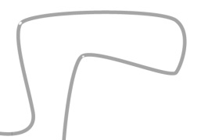  Metal course | 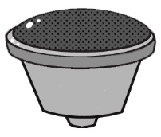  Buzzer |   Light bulb
- It is advised that teachers test the buzzers and light bulbs prior to the assessment lessons to ensure they are in working order.
- One component does require assembly — the wire loop, handle and connecting wire. Note: This part of the Steady Hand Game includes a deliberate fault (i.e. shown in Step 2) that students must identify as part of the assessment task. Use the casing of a pen or a piece of wooden dowel for the handle. Use electrical tape or similar to secure the loop and connecting wire to the handle and visibly disguise the fault.
- Construct enough wire loops, handles and connecting wires for students as shown below.
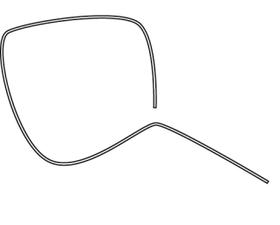  Step 1 | 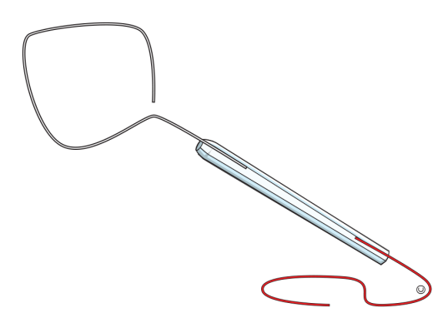  Wire loop and connecting wire not joined  Step 2 | 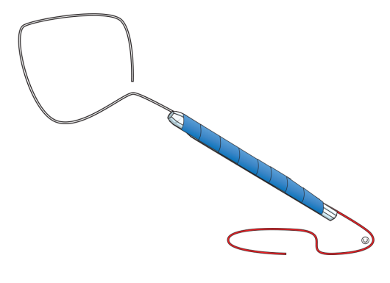  Step 3
Part A: Circuits
Teacher:
- Provide students with their equipment.
- Direct students to answer questions 1 and 2. If assessment tasks are printed in black and white, you may wish to display the Steady Hand Game images in colour.
- Check students’ device designs to ensure safety and practicality.
- Direct students to answer questions 3–7.
Students:
- Construct a circuit to test each component. (Refer to the sheet Investigating electrical conductors and insulators for similar methods.)
Part B: Energy sources
Teacher:
- Direct students to complete questions 1–4 individually.

